***Drowsiness Alertness Using Machine Learning Technique***

1 Rohit Gusain, 2 Ms. Nancy

1,2Department of Computer Science & Engineering

1,2,3Noida Institute of Engineering and Technology, India

1 jhurohit@gmail.com

1. **Abstract**

In India, many accidents occur every day due to breakdowns. As the population grows, so does the number of cars and accidents. Most accidents occur because people feel drowsy, speedy, drunk, or driving. Therefore, we will analyze the data of the past few years, investigate the main causes of accidents, and introduce an accident prevention system to deal with the problem of accidents caused by human sleep and drowsiness. In India, many accidents occur every day due to breakdowns. No. As the population grows, so does the number of cars and accidents. Therefore, we will introduce an accident prevention system to deal with the problem of accidents caused by drowsiness and drowsiness. As computer vision technology advances and advances, smart / smart cameras are being developed that predict driver fatigue and warn drivers. This can reduce accidents when the driver is tired. This task uses deep learning to follow a new approach to detect driver drowsiness based on the condition of the eyes while driving the vehicle. Histogram equalization and cany edge detection algorithms are used in this task to detect faces and extract eye areas from face images.

Keywords: Drowsiness Detection, Machine Learning, Computer Vision, Data Analysis.

1. **Introduction**

In automotive safety technology, driver drowsiness detection is very important to prevent traffic accidents. Today, many people use cars for daily commuting, higher standards of living, comfort, and time constraints to reach their goals. According to the National Road Safety Authority, about 100,000 police-reported accidents each year are associated with sleepy driving. These accidents killed more than 1,550 people and injured 71,000. According to police officers patrolling highways and arterial roads here, sleep-deprived drivers are responsible for about 40% of road accidents. According to a survey by the Central Road Research Institute (CRRI), exhausted drivers who fall asleep while driving are responsible for about 40% of road accidents. While driving the vehicle, various signs of driver fatigue are observed, including: B. You can't keep your eyes open, yawn frequently, move your head forward, etc. Various means are used to determine the level of fatigue of the driver. These measurements are physiological, behavioral, and vehicle-based measurements. Physiological measurements use electrocardiogram (ECG), electroencephalogram (EEG), and electrocardiogram (EOG) to access the driver's condition. Although these devices provide accurate results, they are not widely accepted due to practical limitations. Vehicle-based measurements use steering wheel movements and braking patterns to analyze fatigue. A face detection algorithm was used to identify the face area from the input image during the face detection phase. [9][10][11]

**II. LITERATURE SURVEY**

Drowsiness is one of the leading causes of road accidents and deaths around the world. To address this imminent global problem, researchers continue to develop driver drowsiness detection systems that use a variety of means. However, most studies on drowsiness detection use a single metric-based approach that has not been sufficiently reliable and valid for implementation in vehicles. METHODS: This study explores the usefulness of drowsiness detection based on a singular and hybrid approach. This approach considers a set of metrics from three physiological signals: electroencephalography (EEG), electrocardiogram (EOG), and electrocardiogram (ECG), and ground truth the subjective drowsiness index (assessed by the Karolinska drowsiness scale). Used as. The methodology consisted of signal recording, pretreatment, extraction, and determination of key features from physiological signals to detect drowsiness by the Psychomotor Alert Test (PVT). Finally, four supervised machine learning models were developed based on the subjective drowsiness response, which uses extracted physiological features to detect the level of drowsiness. Results: Results show that a single physiological measurement shows a particular pattern of performance metrics, is sensitive, less specific, or vice versa. In contrast, hybrid bio signal-based models provide better performance profiles and reduce discrepancies between the two metrics. Conclusion: The results of the study show that the selected features performed better in the hybrid approach than in the single approach. This may help in the impact of future research. Practical application: The use of the hybrid approach seems to be justified to improve the driver's drowsiness detection system in the car. Practical applications need to consider factors such as intrusion, ergonomics, cost-effectiveness, and ease of use of the drowsiness detection system. [1]

Drowsiness is a major cause of road accidents and deaths around the world. To address this imminent global problem, researchers continue to develop driver drowsiness detection systems using a variety of means. However, most studies on drowsiness detection use a single metric approach that is not reliable and effective enough for vehicle implementation. METHODS: This study explores the usefulness of drowsiness detection based on the unique hybrid approach. This approach considered a set of metrics from three physiological signals. Driver drowsiness is one of many reasons for recent road accidents. When Intelligent / Intelligent Cameras are developed due to advances in computer vision technology By detecting drowsiness of the driver and warning the driver, the following accidents are reduced. You are tired. This work proposes a new framework that uses deep learning for detection. Driver drowsiness due to eye conditions while driving a vehicle. Detection and Face Extraction This task uses the Viola-Jones face detection algorithm to extract eye areas from a face image. Deep convolution stack neural networks are designed to dynamically extract features. A keyframe identified from the camera sequence and used during the learning phase. There is a SoftMax layer The CNN classifier is used to classify drivers as sleeping or not sleeping. This system warns the driver An alarm sounds when the driver becomes sleepy. The proposed work will be evaluated based on the data collected. This is a 96.42% more accurate dataset than a traditional CNN. Or , for example, the accuracy of the pose on the traditional CNN constraint B . We recommend using deep CNN. -ECG (EEG), EKG (EOG), EKG (EKG)-The subjective drowsiness index (determined by the Karolinska Fatigue Scale) was used as the basic truth. The methodology consisted of signal recording, preprocessing, extraction, and determination of key features from the physiological signals to detect drowsiness by the Psychomotor Alert Test (PVT). Finally, four supervised machine learning models were developed based on the subjective drowsiness response. It uses extracted physiological features to detect the level of drowsiness. Results: The results show that a single physiological measurement shows a particular pattern of performance metrics, is sensitive, less specific, or vice versa. In contrast, the hybrid bio signal-based model provides a better performance profile and reduces discrepancies between the two metrics. Conclusion: The results of the study show that the selected characteristics are superior to the hybrid approach over the individual approach. This will help the impact of future research. Practical application: The use of the hybrid approach seems to be justified to improve the driver's drowsiness detection in the car. Practical application needs to consider factors such as engagement, ergonomics, cost effectiveness, and ease of use of the drowsiness detection system. [2]

In automotive safety technology, driver drowsiness detection is very important to prevent traffic accidents. Today, many people use cars for daily commuting, higher standards of living, comfort, and time constraints to reach their goals. According to the National Road Safety Authority, about 100,000 police-reported accidents each year are associated with sleepy driving. These accidents killed more than 1,550 people and injured 71,000. According to police officers patrolling highways and arterial roads here, sleep-deprived drivers are responsible for about 40% of road accidents. According to a survey by the Central Road Research Institute (CRRI), exhausted drivers who fall asleep while driving are responsible for about 40% of road accidents. While driving the vehicle, various signs of driver fatigue are observed, including: B. You can't keep your eyes open, yawn frequently, move your head forward, etc. Various means are used to determine the level of fatigue of the driver. These measurements are physiological, behavioral, and vehicle-based measurements. Physiological measurements use electrocardiogram (ECG), electroencephalogram (EEG), and electrocardiogram (EOG) to access the driver's condition. Although these devices provide accurate results, they are not widely accepted due to practical limitations. Vehicle-based measurements use steering wheel movements and braking patterns to analyze fatigue. A face detection algorithm was used to identify the face area from the input image during the face detection phase. [3]

Sleepy drivers are far more dangerous on the road than speed-violating drivers because they are victims of microsleep. Automotive researchers and manufacturers are trying to contain this problem with several technical solutions to avoid such a crisis. This article focuses on detecting such microsleeps and drowsiness using neural network-based methods. Previous work in this area has used multi-layer perceptron machine learning to detect the same. In this article, the accuracy was improved by using facial features that were detected by the camera and passed to a convolutional neural network (CNN) to classify drowsiness. The success of this task is a feature that provides a lightweight alternative to heavier classification models, with over 88% in the no glasses category and over 85% in the night without glasses category. On average, over 83% accuracy was achieved in all categories. In addition, in terms of model size, complexity, and memory, the newly proposed model has been significantly reduced compared to the benchmark model with a maximum size of 75 KB. Using the proposed CNN-based model, you can build a real-time drowsiness detection system for embedded systems and Android devices with high accuracy and ease of use. [4]

Sleepy drivers are far more dangerous on the road than speed-violating drivers because they are victims of microsleep. Automotive researchers and manufacturers are trying to contain this problem with several technical solutions to avoid such a crisis. This article focuses on detecting such microsleeps and drowsiness using neural network-based methods. Previous work in this area has used multi-layer perceptron machine learning to detect the same. In this article, the accuracy was improved by using facial features that were detected by the camera and passed to a convolutional neural network (CNN) to classify drowsiness. The success of this task is a feature that provides a lightweight alternative to heavier classification models, with over 88% in the no glasses category and over 85% in the night without glasses category. On average, over 83% accuracy was achieved in all categories. In addition, in terms of model size, complexity, and memory, the newly proposed model has been significantly reduced compared to the benchmark model with a maximum size of 75 KB. Using the proposed CNN-based model, you can build a real-time drowsiness detection system for embedded systems and Android devices with high accuracy and ease of use. [5]

Sleep deprivation (drowsiness) is recognized as a global problem because of the health and safety risks of people engaged in activities that require constant attention. Therefore, several computer vision-based non-invasive techniques have been proposed for timely detection of drowsiness. However, these methods are usually based on sleepy behavioral indicators such as yawning and excessive blinking. In addition, results are usually reported for databases with very few subjects or databases of sleepy data. This paper proposes a technique for detecting drowsiness based on hybrid characteristics using comprehensive and challenging real-world drowsiness data. Analysis of eye condition and body movements is performed primarily to determine drowsiness. To remedy this, the eye area is selected from each frame using facial landmarks and described using a histogram of oriented gradient descriptor (HoG). To illustrate body movements, frame differences are calculated and parameterized using the HoG descriptor. Next, the hybrid feature set, i. H. A combination of eye and body movement features that are targeted for dimensionality reduction by principal component analysis. Finally, the SVM is trained and tested with a set of hybrid functions to detect drowsiness. Achieves 90% detection accuracy by the proposed method. [6]

Over the years, advances in computer technology have assisted drivers primarily in the form of intelligent vehicle systems. Driver drowsiness is an important factor in many car accidents. Therefore, it is thought that there is great potential for detecting drowsiness in order to prevent traffic accidents caused by sleep. This paper proposes a visual-based intelligent algorithm for detecting driver fatigue. Previous approaches are generally based on blink rate, eye closure, yawning, eyebrow shape, and other crafted facial features. The proposed algorithm explicitly captures the interaction of various potential facial features with complex nonlinear features using features learned using a convolutional neural network. Softmax shifts are used to classify drivers as sleepy or not sleepy. Therefore, this system is used to warn drivers of drowsiness and avoid traffic accidents. It presents both qualitative and quantitative results to support the claims made in the work. [7]

This paper presents a literature review of driver drowsiness detection based on behavioral measurements using machine learning techniques. The face contains information that can be used to interpret the level of drowsiness. There are many facial features that can be extracted from the face to infer the level of drowsiness. These include blinking, head movements, and yawning. However, developing a fatigue detection system that provides reliable and accurate results is a daunting task due to the need for accurate and robust algorithms. Various techniques have been investigated in the past to detect drowsiness in drivers. With the recent rise of deep learning, these algorithms need to be revised to assess their accuracy in detecting drowsiness. As a result, this article describes machine learning techniques, including support vector machines, convolutional neural networks, and hidden Markov models in the context of drowsiness detection. In addition, a meta-analysis is performed on 25 articles that use machine learning techniques to detect drowsiness. Analysis shows that the support vector machine method is the most commonly used method for detecting drowsiness, but convolutional neural networks perform better than the other two methods. Finally, this paper lists published datasets that can be used as benchmarks for drowsiness detection. [8]

1. **Proposed Methodology**

Program shows how to find frontal human faces in an image and estimate their pose. The pose takes the form of 68 landmarks.These are points on the face such as the corners of the mouth, on the eyes, and so forth.

* When either no face is detected or the calculated aspect ratio is less than or equal to the threshold value, Alert message would be displayed.
* When Mouth Aspect Ratio is greater than Mouth Threshold Value, Notification for ‘Yawning’ would be displayed.
* When Eyes Aspect Ratio is greater than Eyes Threshold Value, Notification for ‘Sleeping’ would be displayed.
* When Eyes Aspect Ratio and Mouth Aspect Ratio are greater than Eyes Threshold Value and Mouth Threshold Value respectively, Notifications for ‘Sleeping and Yawning’ would be displayed.

You can compute "Eye Aspect Ratio"(EAR) using the formula given in research paper specified in references-



You can compute "Mouth Aspect Ratio"(MAR) using the formula-

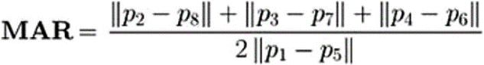

we also had done sone analysis on data using below techniques to predict accident cases in india.

1. Data Loading

It is a way to load data from file, folder or any application to dataset. Data loading can be done using a python library called NumPy which convert data into data frame type [7]

1. Exploratory Data analysis

It is a crucial technique of activity preliminary investigations on information therefore on determine patterns, to spot irregularities, to test hypothesis and to envisage assumptions with the assistance of outline statistics and graphical representations.

1. Data Pre-Processing

It is data mining technique which involves data transformation of raw data into an understandable term [7].

1. Data Splitting

In data splitting the data should be divided into two parts training data.

1. Model

A machine learning model is a file which has been trained to recognize different patterns. We can make a model by training different data sets by providing an algorithm to data from which it can easily learn from those data [8].

**III.i Data mining and Data transformation**

In data analysis first we used different sources  to collect data. Data collection is the most important part for any predictive modeling. How much the data is qualitative and quantitative the prediction accuracy is more good. So, here are the five different stages of data mining process we used.

1. Data cleansing :

In this process we used to do different techniques to make our data clear. Data cleaning is the process in which we detect and clean the inaccurate data and in this process we also remove, replace and modifiy the dirtiness or coarse data with worldwide values or predictable or mean values.

1. Data integration

A cycle incorporates coordinating a clever arrangement of information with a current gathering. The source, nonetheless, may incorporate various informational collections, sites or level documents. The normal execution of information incorporation makes the EDW (venture information stockroom), and afterward discusses two ideas - tight and free coupling, however we should not disregard the subtleties.

C.Data transformation

This requires the transformation of information inside designs, ordinarily from the source framework to the expected framework. Different techniques incorporate Normalization, Aggregation, Smoothing, Generalization and trait development.

D. Concept hierarchies

They decrease information by replacement and gather low-level ideas in significant level ideas. Reasonable ordered progressions characterize the complex information with numerous degrees of reflection. Techniques are Binning, bunch analysis,histogram examination, and so on.

E. Pattern evaluation and data presentation

Assuming that the information is first rate, the client and clients can involve it in the most ideal manner. Subsequent to going through the above segments, the information is given charts and graphs and accordingly comprehended with negligible factual information.

**III.ii Machine learning training**

In the human brain (the Artificial intelligence and machine learning learning that seeks to mimic it), pattern recognition is a process of understanding what happens in the brain as similar to the information we see and the data stored in our memories. If we are talking  about computer science, however, pattern recognition is a technology such as incoming data and information stored in a database. Thus, pattern recognition is a form of machine learning as it uses machine learning algorithms to identify patterns.

Pattern recognition and machine learning detects data features that reveal information about a particular data set or system and is characterized by the following four characteristics:

* Reading from data
* It automatically detects patterns even if it is slightly visible
* Can detect common patterns
* Recognition comes from different shapes and angles

In other words, pattern recognition and machine learning are two sides of the same coin.

**III.iii Algorithm**

Here, are the Some machine algorithms which are used two forecast accident cases.

**K-nearest neighbors**

K-NN is a non-parametric and lazy learning algorithm. Non-parametric means there is no assumption for underlying data distribution i.e. the model structure determined from the dataset. It is called Lazy algorithm because it does not need any training data pointsfor model generation. All training data is used in the testing phase which makes trainingfaster and testing phase slower and costlier. In K-NN classification, the output is a classmembership. An object is classified by a plurality vote of its neighbors, with the objectbeing assigned to the class most common among its k nearest neighbors (k is a positiveinteger, typically small). To determine which of the K instances in the training dataset aremost similar to a new input, a distance measure is used. For real-valued input variables,the most popular distance measure is the Euclidean distance.

**Naive bayes**

A Naive Bayes classifier is a probabilistic machine learning model that is used for classi-fication task. The crux of the classifier is based on the Bayes theorem. It is a generativeclassifier where features are often assumed to be of Gaussian distribution and also sta-tistically independent from one another.This assumption is usually false. That’s why it’susually known as a naive Bayes classifier. The Naive Bayes Classifier can produce veryaccurate classification results with a minimum training time when compared to conven-tional supervised or unsupervised learning algorithms.

**Random Forest Regression**

Random Forest is a supervised learning algorithm.It creates a forest and makes it some-how random.The forest“ it builds, is an ensemble of Decision Trees.Random Forest adds additional randomness to the model, while growing the trees. Instead of searching for the most important feature while splitting a node, it searches for the best feature among a random subset of features. This results in a wide diversity that generally results in a better model.

**Support Vector Machine**

Support vector machines are supervised learning models with associated learning algo-rithms that analyze data used for classification and regression analysis. SVM or SupportVector Machine is a linear model for classification and regression problems. It can solvelinear and non-linear problems and work well for many practical problems. The idea ofSVM is simple: The algorithm creates a line or a hyperplane which separates the datainto classes. Degree of confidence measure the probability of misclassification.

**Comparison of Implemented Algorithms**

The following table shows maximum accuracy values corresponding to each algorithm-

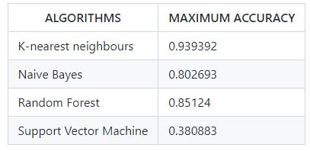

**III.iv Graphical Representation of Covid Data**

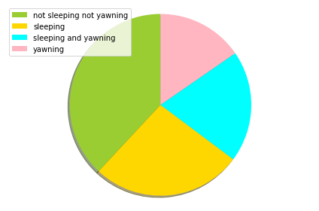

**Using analysis of data here we plot a pie chart through which we can measure the activities of people while the driving.**

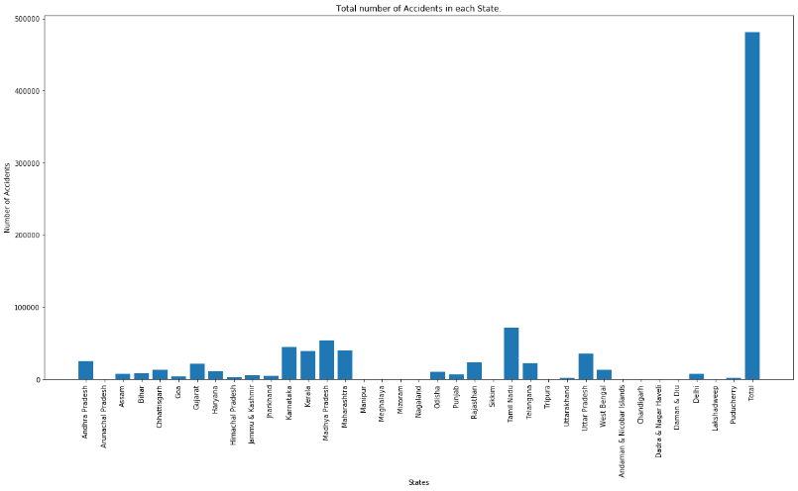

**Also same with bar plot we created a count state through which we can count the number of accidents which casuse through drowsiness and or getting dozzed off.**

**V. CONCLUSION**

We conclude that by designing a drowsiness detection model we can easily safe some lives. Using this model, we can avoid number number of accident cases if an alert sent to a driver that he is drowsy. It alerts the truck driver as well as owner of that truck driver. In this paper we also conclude number of accident cases in India using previous years accident cases data

**VI. REFERENCE**

1. <https://www.sciencedirect.com/science/article/pii/S0022437521001523>
2. <https://www.researchgate.net/profile/U-Srinivasulu-Reddy/publication/338251837_Deep_CNN_A_Machine_Learning_Approach_for_Driver_Drowsiness_Detection_Based_on_Eye_State/links/5f012fc192851c52d619b0cb/Deep-CNN-A-Machine-Learning-Approach-for-Driver-Drowsiness-Detection-Based-on-Eye-State.pdf>
3. <https://link.springer.com/chapter/10.1007/978-0-387-79582-9_8>
4. <https://research.sabanciuniv.edu/id/eprint/10444/>
5. <https://ieeexplore.ieee.org/abstract/document/9089484>
6. <https://ieeexplore.ieee.org/abstract/document/9608977>
7. <https://ieeexplore.ieee.org/abstract/document/6779459>
8. <https://ieeexplore.ieee.org/abstract/document/8261140>
9. https://www.ijert.org/a-machine-learning-approach-for-driver-drowsiness-detection-based-on-eye-state
10. https://www.ncbi.nlm.nih.gov/pmc/articles/PMC3571819/
11. https://www.researchgate.net/publication/338251837_Deep_CNN_A_Machine_Learning_Approach_for_Driver_Drowsiness_Detection_Based_on_Eye_State
12. https://www.nhtsa.gov/press-releases/early-estimate-2021-traffic-fatalities#:~:text=The%20National%20Highway%20Traffic%20Safety,the%2038%2C824%20fatalities%20in%202020.